SANTOS, Chris Micael Cruz March 09, 2015

REYES, Christian Joseph Rizal Course

2CSA Quiz #2

**Creative Timeline of Rizal’s Travels**

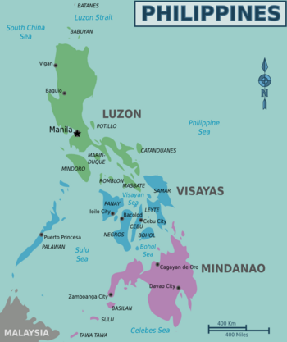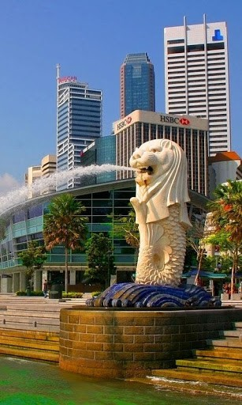

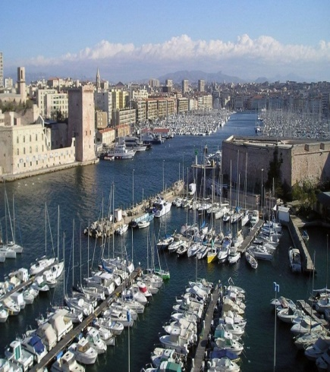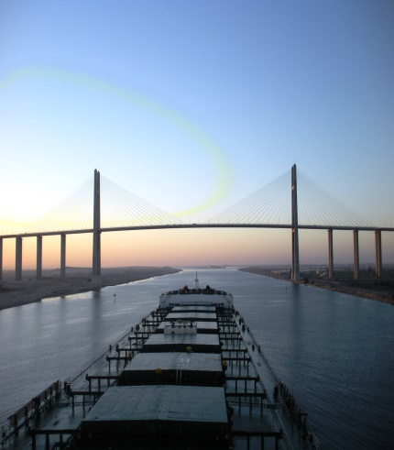

**3 May 1882**  
Rizal left Philippines for the first time to go to Spain. He boarded the Salvadora using a passport of Jose Mercado, which was procured for him by his uncle Antonio Rivera, father of Leonor Rivera. He was accompanied to the quay where the Salvadora was moored by his uncle Antonio, Vicente Gella, and Mateo Evangelista.

**13 June 1882**  
Early on the morning he landed at Marseilles and boarded at the Noalles Hotel. Later he went around for observation.

**9 May 1882**  
Rizal arrived at Singapore. In Singapore, at 2 p.m., Rizal boarded the boat Djemnah to continue his trip to Spain. He found the boat clean and well kept.

**2 June 1882**  
He arrived at the Suez Canal en route to Marseilles. He was quarantined on board the Djemnah in the Suez Canal.

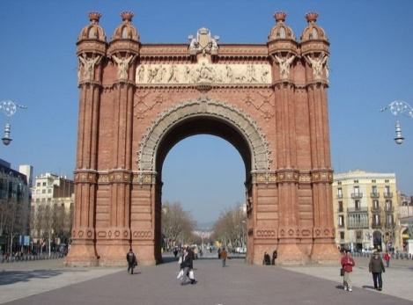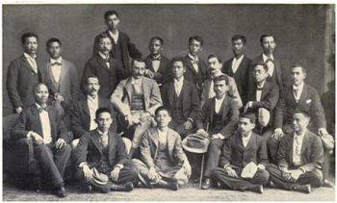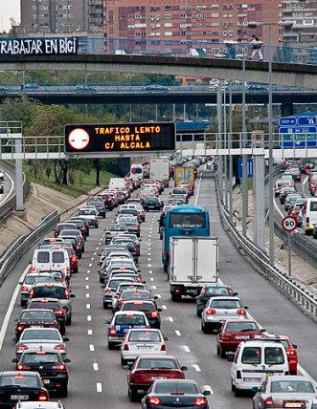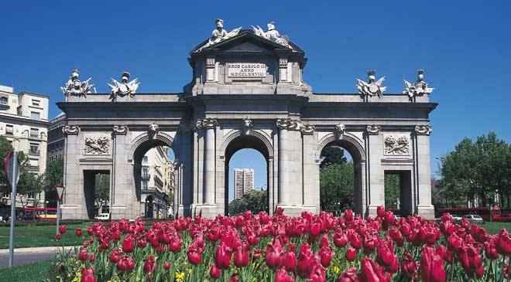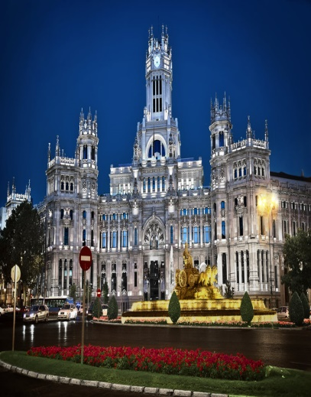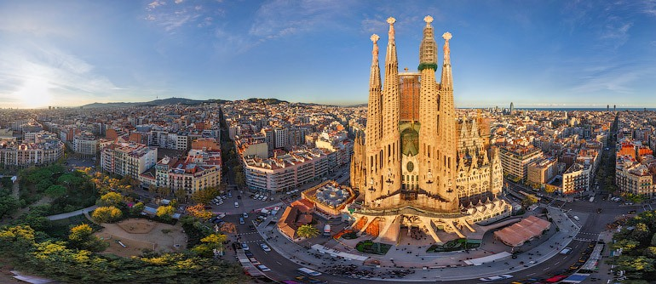

**17 June 1883**  
Rizal arrived at Paris. He spent the whole day walking around and observing the beautiful cities.

**4 October 1882**  
Asked to deliver a poem by the members of Circulo Hispano-Filipino, there together in the effort to save the association from disintegration, Rizal recited "Me piden versus." The meeting was held at the house of Pablo Ortiga y Rey.

**15 June 1883**  
Rizal left Madrid for Paris to spend his summer and to observe the big French City.

**30 December 1882**  
In a letter, Rizal revealed to Paciano his plan of going to Paris or Rome in June. He wanted to practice French in Paris and Italian in Rome and to observe the customs of people in those cities.

**2 September 1882**  
Rizal matriculated at the Universidad Central de Madrid. He took the following subjects: medical clinic, surgical clinic, legal medicine and obstetrical clinic.

**16 June 1882**  
At 12:00 noon, Rizal arrived at Barcelona and boarded in the Fonda De España. In a letter, Rizal related to his parents his experiences during his trip from Port Said to Barcelona. In the same Letter, he requested them to send him a birth certificate and statement showing that he had parents in the Philippines.

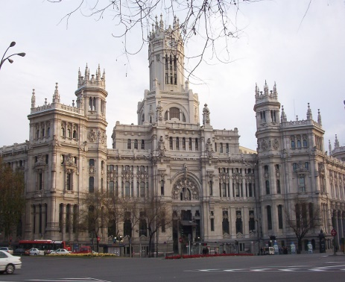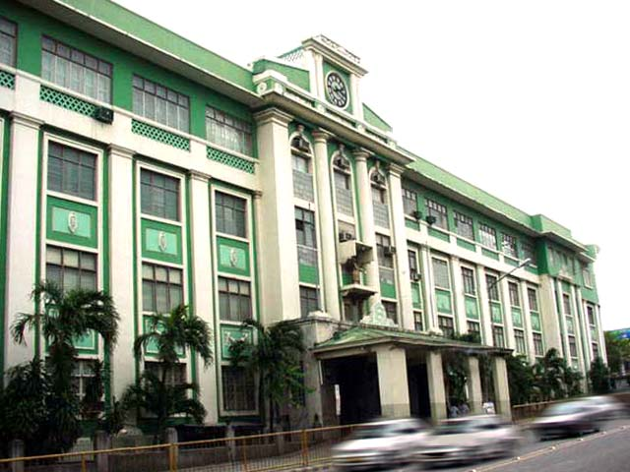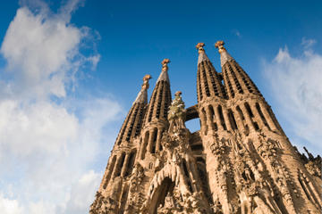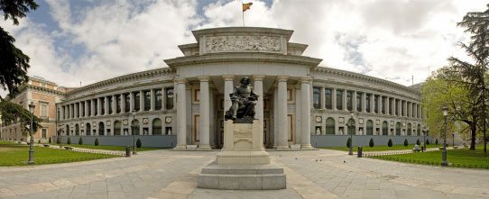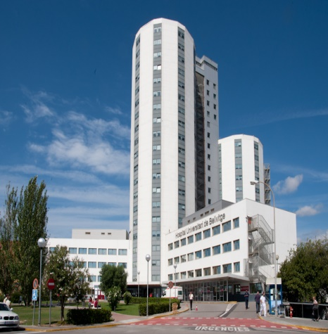

**21 June 1884**  
He finished the degree of Licentiate in Medicine with the grade of aprobado from the Central Universidad de Madrid.

**28 January 1884**  
He visited the Ateneo with Antonio and Maximino it was beautiful, wide and well decorated. He met beautiful girl at the door of his neighbor’s house.

**3 January 1884**  
Early in the morning, Rizal went to the University of San Carlos only to find out that there was no class. He immediately went to the Café de Madrid to meet members of the Circulo who were gathered again to discuss the proposed book. Rizal proposed to the member of the Circulo assembled in the house of the Pateros, the publication of a book by association. This idea became the embryo of this first novel Noli Me Tangere .

**20 August 1883**  
Rizal was back in Madrid from his summer vacation in Paris. He had a new address. He live with Eduardo Lete and the two Llorente brothers, Julio and Abdon, in Bano 15 Pral.

**5 July 1883**  
In a letter to his parents, sisters and brother, Rizal continued describing the museum, buildings and hospitals he had visited in Paris.

**18 June 1883**  
With Felipe Zamora and Cunanan, He visited the Leannec Hospital to observe how Dr, Nicaise treated his patients. He was stunned to see the advanced facilities in the accommodation in the said hospital.



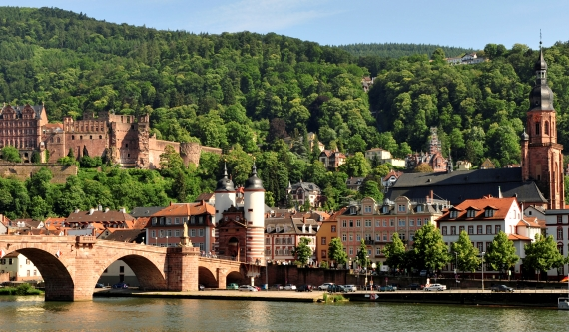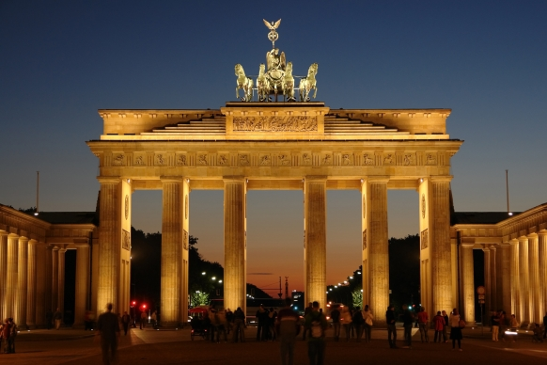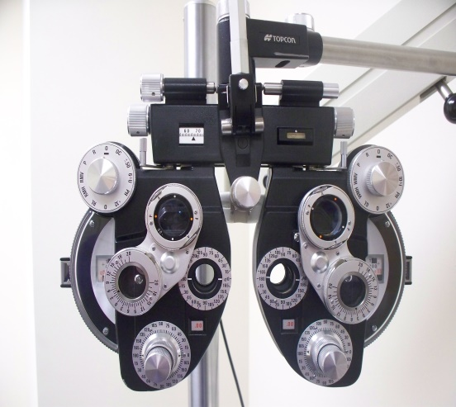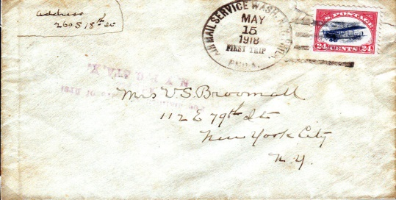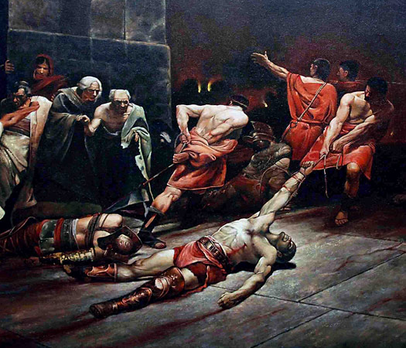

**22 April 1886**While in Heidelberg experiencing the feeling of nostalgia for his parents and his country, Rizal wrote the poem "A Las Flores de Heidelberg."

**19 June 1885**Rizal finished the degree in Licentiate in Philosophy and Letters with grade sobresaliente from the Central Universidad of Madrid.

**2 February 1886**  
Rizal arrived at Strasburg, Germany. He visited the celebrated cathedral and climbed a tower of 142 meters high, the fourth highest of the European towers.

**4 December 1885**  
He was practicing ophthalmology with Dr. Weeker at the Crugen Clinic.

**1 January 1885**  
Paciano begged Rizal to wait for the opportune time to return to the Philippines. In a letter, he told Rizal that their parents would see him in Hong kong sometime in the future, and not in the Philippines were the situation was dangerous for him. Paciano asked for some information about sugar beets in Europe, and advised Rizal to write tell their parents things that would always please them.

**16 November 1884**  
He wrote a letter to his family in Calamba asking their permission for him to return to the Philippines.

**25 June 1884**  
Rizal won first prize in Greek contest, after which he delivered a speech in honor of the two Filipino painters, Juan Luna and Felix Resurreccion Hidalgo. The occasion commemorated the triumph of the two, especially Luna who won the first prize for his Spoliarium during the National Exposition of Fine Arts held in Madrid that year.

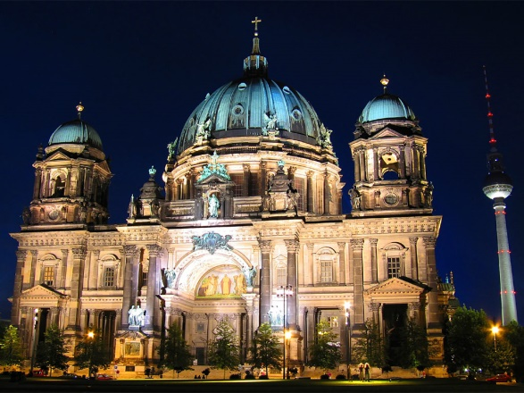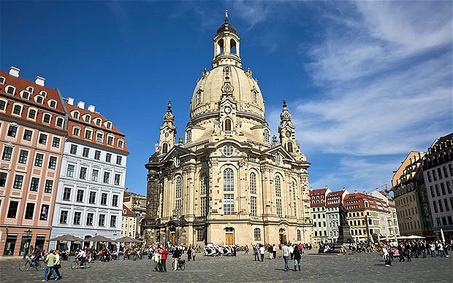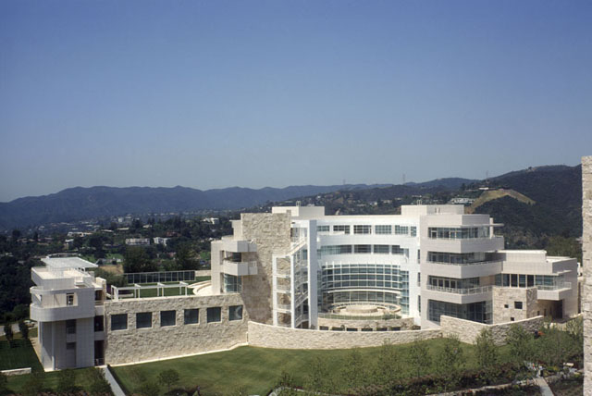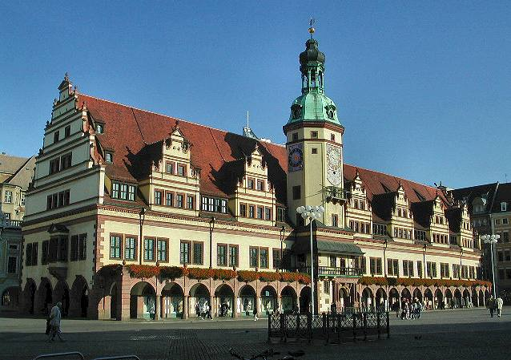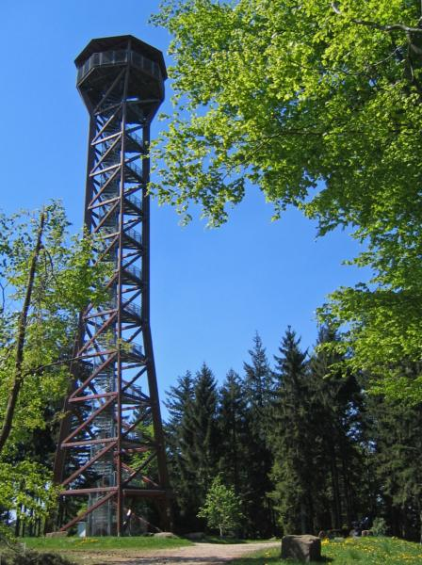

**1 November 1886**  
At 1:25 P.M., Rizal arrived at Berlin and boarded at the Central Hotel.

**11 December 1886**  
Maximo Viola joined Rizal in Berlin. Rizal was not able to meet Viola at the station because the former was sick.

**January 1887**  
He became a member of the Ethnographic Society of Berlin in whose meeting he had the rare opportunity of hearing the interesting lecture of Dr. Donitz on pre-historic Japanese tombs which contained sets of dishes and other decorations.

**29 October 1886**Rizal arrived at Dresden at 8:20 in the morning.

**31 October 1886**In Dresden, he met Dr. A.B. Mayer, naturalist of the Dresden University. He was shown interesting things taken from the Palaos Islands and from tombs in the Philippines.

**14 October 1886**He got acquainted persolly with Doctor Hans Meyer, chief of the Bibliographical Institute of the Germany, and author of one of the two famous encyclopaedical dictionaries of Germany.

**21 October 1886**Rizal left Leipzig for Halle to observe the country life of the people there. He returned in the afternoon.

**9 August 1886**  
Rizal left Hiedelberg for Leipzig

**15 August 1886**Rizal arrive at Leipzig at 9:30 in the morning.

**14 July 1886**Back in Hiedelberg, Rizal was admitted member of the chess Club Germany. The Club Presidents F. Zeferenz and E.Arrnirum.

**26 April 1886**He left Heidelberg for Wilhemsfeld to honor invitation extended to him by Reverend Karl Ullmer whom Rizal meet one day in the woods with the Pastor’s wife, daughter Eta and son Freidrich. In Wilhelmsfeld where Pastor Ullmer was staying and working, Rizal was invited to visit the vicarage. Later, on Rizal’s choice, he boarded with the Ullmer family until he left Wilhelmsfeld by last week of June.

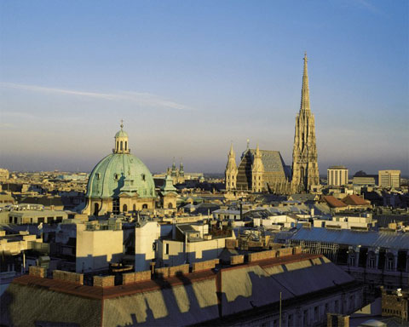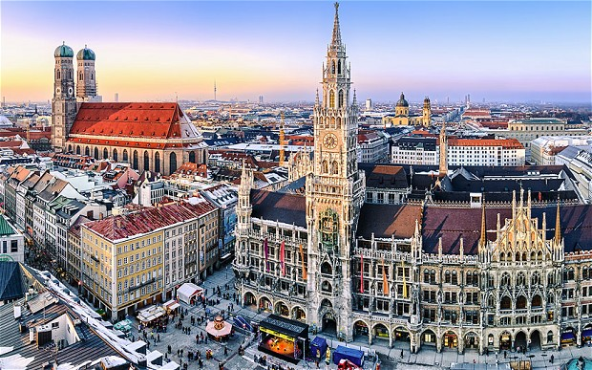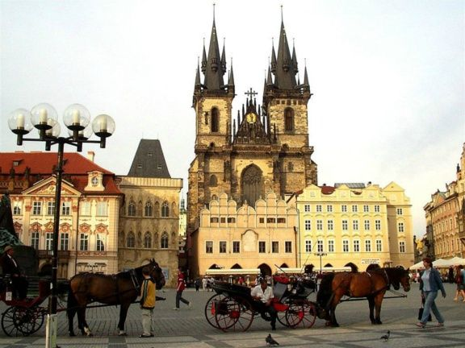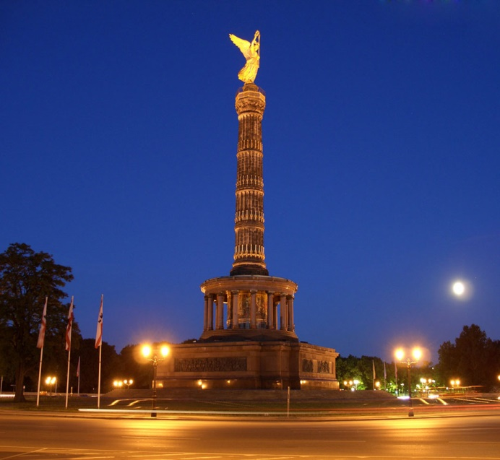

**13 May 1887**Rizal and Viola arrived at Leitmeritz at 1:30 in the afternoon. They were met at the station by Prof. Blumentritt who conducted them to the Krebs Hotel, Room No. 12.

**14 May1887**Rizal and Viola attended the session of the Board of Directors of the Tourist Club in Leitmeritz thru the invitation of Prof. Blumentritt who was the club secretary. They were cordially received by the President of the Club, Jose Krombholz. Rizal delivered an extemporaneous speech in German, which was very much applauded by the audience for his fluency.

**15 May 1887**With Prof. Blumentritt as their guide, Rizal and Viola visited the churches , the residence of the Bishop and other important buildings of the city. They also visited the special friend of Prof. Blumentritt, Dr. Carlos Czepelak, who wanted very much to see Rizal personally.

**17 May 1887**Rizal decided to left for Vienna and Munich.

**26-30 May 1887**  
They left Vienna and went to Munich. Rizal and Viola were boarders of Rheinischer Hof or Rhine Hotel in Munich for five days. On May 29, 1887, they drunk beer in the business establishment, LowerbranKeller Munich.

**20-24 May 1887**Rizal and Maximo Viola arrived in Vienna at 2:30 P.M. of May 20th and both boarded at the Hotel Metropole. 24 May 1887. For the last 3 days, they were conducted around the city by Mr. Masner to see the points of interest, especially the Museum. On this day, Rizal was interviewed by Mr. Alder of the newspaper Extra Blatt.

**19 May 1887**  
Rizal bade goodbye to Prof. Dr. Willkomn, State Adviser in Brunn. The lovable daughter of the professor reproached Rizal for not having told them of his artistic and poetic talents which they read in Bohemia, a newspaper published in Prague. They left Brunn this day.

**11 January 1887**  
He met personally Dr. Teodor Jagor who invited him to attend the monthly luncheon of the member of the Geographic Society. In one of luncheons, he came to know the famous Virchow, president of the Anthropological Society of Berlin.

**February 1887**  
He became a member of the Anthropological Society and the Geographic Society of Berlin.

**29 March 1887**In grateful appreciation of Maximo Viola’s pecuniary aid, Rizal presented him the last galley proofs and the first bound copy with this dedication: "To my dear friend, Maximo Viola, the first to read and appreciate my work- Jose Rizal, March 29, 1887, Berlin."

**11 May 1887**  
Accompanied by Maximo Viola, Rizal left Berlin to visit the cities of Eurupe, including Dresden, Leitmeritz, Prague, Vienna, Munich, Nuremberg, Ulm, Lausanne, and Geneva.

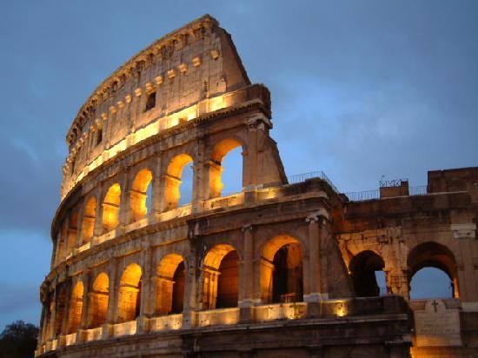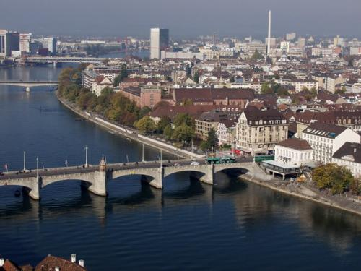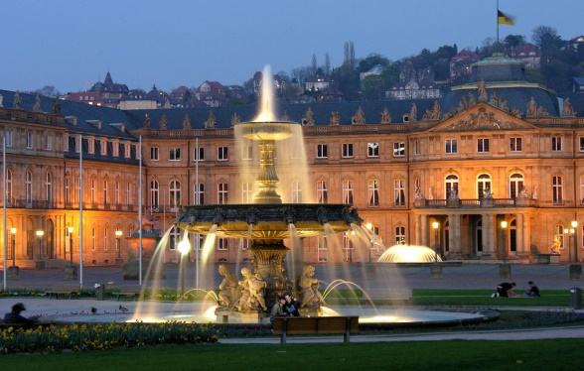

**September 1887**  
Rizal decided not to leave his family within this year. His sister Olimpia died of hemorrhage while giving birth.

**3 February 1888**  
Rizal, after staying in the Philippines for almost six months, left Manila for Hongkong, bringing with him P5,000 which he earned from his medical practice.

**5 August 1887**  
At 9:00 o’clock in the evening, Rizal arrived at Manila after five years of study and patriotic labors in Europe.

**3 July 1887**Rizal was in the Bureau of Posts of Marseilles at 8 o’clock in the morning. He received two letters there: One form Manuel Hidalgo and the other from Ferdinand Blumentritt. He left Marseilles bound for his homeland on board the boat Djemnah on the same day.

**27 June 1887**Rizal arrived at Rome and walked around the whole day. He visited the Capitolio, the Roca Tarperya, the Palatinum, the Forum Romanun, the Museum Capitolinum and the church of Santa Maria, the maggiore. He tool a flower from the Palace of Septimius Severus, which he sent to Blumentritt

**29 June 1887**From Rome, Rizal wrote his father: "I was in Turin, Milan, Venice, Florence, and for some days I have been here." Heannounced his return to the Philippines between the 15th and 30th of August.

**19 June 1887**With Maximo Viola, Rizal celebrated his 26th birthday in Geneva, Switzerland. His attitude towards revolution was manifested in his letter to Blumentritt on the following terms: "I do not have interest of taking part in any conspiracy, which seems to me very premature and risky. But if the government obliges it to us, meaning, when no other hope is left for us than search for our perdition in war, when the Filipinos prefer to die supporting misery, then I shall also become supporter of violent means. It is on the hands of Spain whether to select peace or perdition because it is an evident fact which all know that we are patient, very patient and peaceful."

**23 June 1887**Rizal and Maximo Viola parted at Geneva, after visiting European cities

-Rizal going to Rome and Viola to Barcelona

**31 May, 1887**Rizal and Viola arrived at the Geneva and boarded at the Hotel Merquardt. They left for Basel the following day, June 1.

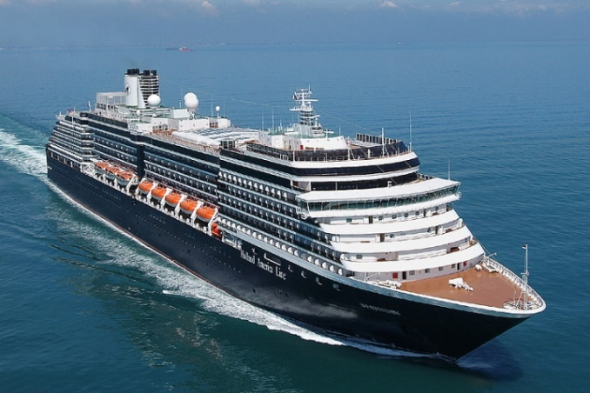

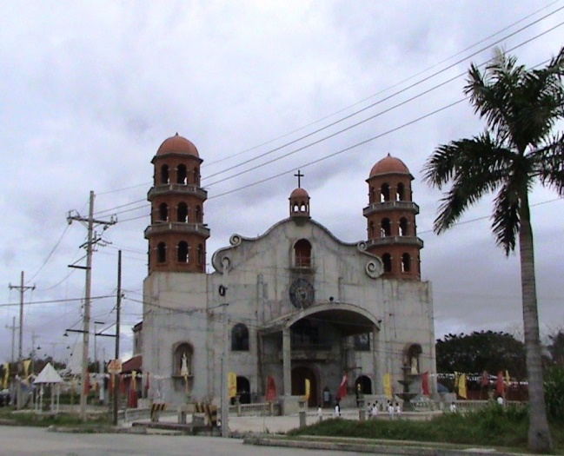



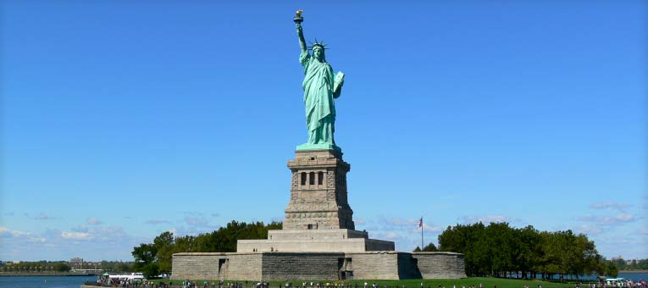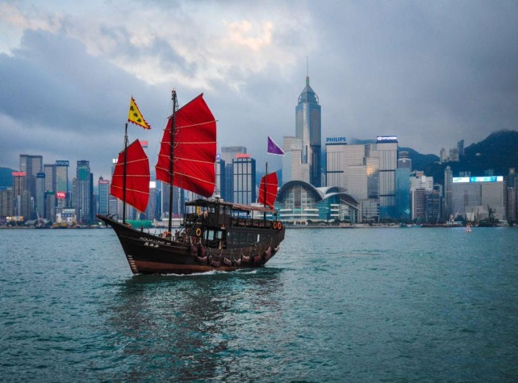

**16 May 1888**  
Rizal departed from New York City on board the City of Rome, bound for Liverpool.

**2 June 1888**  
Dr. Reinhold Rost and family tendered in their house a tea party in Rizal’s honor. Rizal saw in the Rost’s house a good Filipiniana library. (Dr. Reinhold Rost, a book lover, librarian of the Minister of Foreign Relations of England and famous Malayalogist, had especial predilections for Rizal whom he used to call Hombre perla).

**23 June 1888**He thought of publishing the second edition of the Noli Me Tangere with the illustrations of Juan Luna and with slight changes. He wanted to correct the typographical errors and the erroneous citation of Shakespeare which should be that of Schiller.

**18 August 1888**With the intention of writing the continuation of his first novel, Rizal asked Mariano Ponce in a letter to send him two or more copies of the Noli. Rizal planned t hav a picture taken : one copy to be sent to Ponce and the other to be included in the publication of the second novel.

**28 April 1888**  
Rizal arrived at San Francisco, California.

**8 May 1888**He started his trip of the American continent. He passes through Reno, Ogden, Denver, Farmington, Salt Lake City and Provo.

**13 May 1888**He reached Albany and later traveled along the bank of the Hudson River. This day was the end of his transcontinental trip. Arriving at New York on the morning, he boarded at the Fifth Avenue Hotel.

**8 February 1888**  
After 5 days trip, Rizal arrived at Hong Kong. He boarded in the house of Jose Maria Basa.

**19 February 1888**  
With Jose Maria Basa, Jose Sainz de Veranda and some Portuguese, Rizal left Hongkong for Macao on board the Kui Kiang. In Macao, they lived in the house of Juan Lecaroz. Rizal went around for observation, especially the botanical garden.

**22 February 1888**  
After staying in Hong Kong for almost two weeks, he left for Japan on board the Oceanic.

**28 February 1888**Rizal, after days of travel, arrived at Yokohama. He registered at the Grand Hotel. He was offered at once the Spanish Legation for his home. In Japan, Rizal studied the habits and customs of the Japanese people, their language, theaters and commerce.

**15 March 1888**Rizal first saw O-Sei-san walking past the gate of the Spanish Legation.

**13 April 1888**Rizal left Yokohama for San Francisco, on board the Belgic.

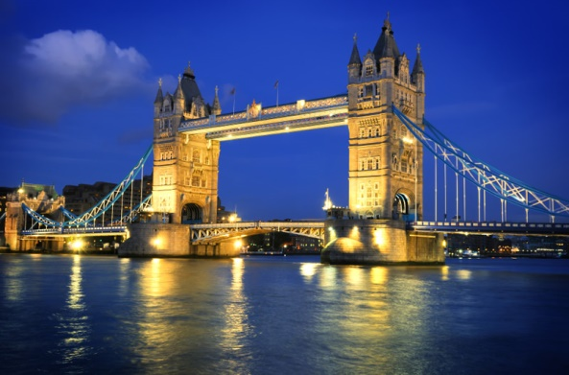

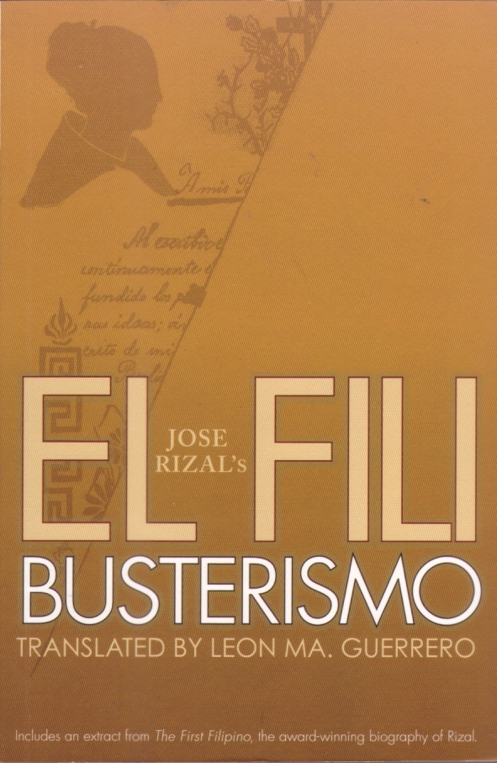

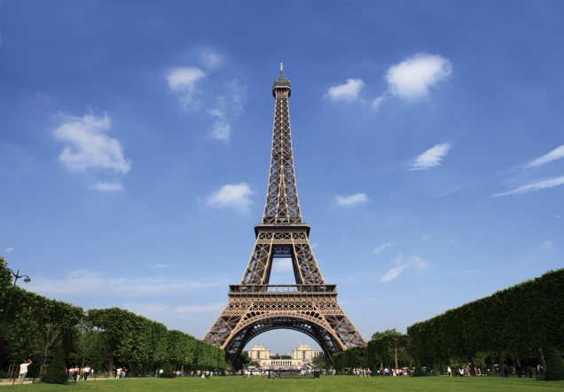

**14-18 November 1888**He was busy reading the book of Gaspar de San Agustin about the Philippines. He found the book full of pessimism especially that part which refers to the Indios. The book would have been one of the best references on Philippines literature if not for this defect, according to Rizal.

**6 December 1888**Rizal received the news that in spite his opposition, he was elected director of the new newspaper. He was the only candidate who met less adversaries. With this outcome, he planned to go to Madrid to see the members of the Filipino Colony.

**8 December 1888**Rizal sent to Dr. Carlos Czepelack his sculptural work Revancha in exchange for the beautiful landscape he received from the latter. During the previous days he read the book of Multatuli, a Dutch author. He found the book similar to his Noli with difference, however, on the strength of attack. Rizal’s attacks are more violent than those of Multatuli’s.

**11 December 1888**He left London for Barcelona and Madrid.

**RIZAL IS BACK IN LONDON**

**19 September 188**Rizal finished copying the whole book of Morga.

**30 September 1888**In a letter, he requested Mariano Ponce to forward to Hongkong the box of Noli so that Jose Maria Basa could send them to the Philippines where the Filipinos needed them.

**12 October 1888**He was admitted to study in the Department of Greek and Roman Antiquities in the British Museum of London.

**4 September 1888**Rizal arrived at Paris and boarded at the Hotel del Restaurant de Rome. Because of the bad news he received from home , he thought of proceeding to Spain. However, the plan was not realized.

**10 September 1888**He left Paris for London to continue copying the book of Morga in the British Museum.

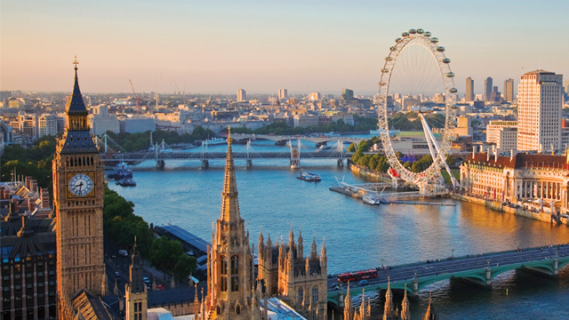

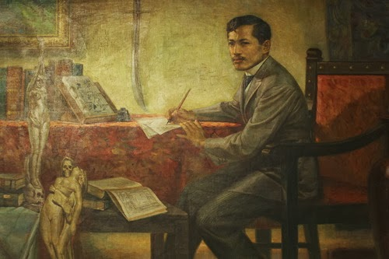



**13 December 1888**  
In Barcelona, he saw the members of the Filipino colony: Mariano Ponce, Fernando Canon, Graciano Lopez-Jaena, and others. They talked much about the Filipinism of Prof. Blumentritt.

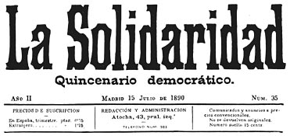

**19 March 1889**Rizal arrived at Paris and immediately founded the Kidlat Club. Since he had no time to publish immediately the annota-tions to the Morgans Sucesos de las Islas Filipinas, he planned to edit the Ethnography of Mindanao together with Blumentritt Defense.

On the same day, Rizal, in Paris, permitted Mariano Ponce to publishthe poem "En Bosque" advising the latter pay attention to the signature Laong Laan. Likewise, advised Ponce to buy Filipino books and to mention its authors from time to time.

**15 December 1889**His essay "Filipinas Dentro de Cien Años" was published in the La Solidaridad (third installment).  
  
His poem the "Las Flores de Heidelberg" signed Laong Laan was published in the La Solidaridad.

**3 January 1890**Rizal who was still in Paris announced to Ponce his return to London.

**24 December 1888**Rizal arrived at London from his twelve days visit to Spain.

**4 February 1889**Rizal rejoiced because of the coming out on the 15th of the month of the publication La Solidaridad in Barcelona. This was communicated to Marcelo H. del Pilar. He urged that one of the Filipinos staying in Barcelona should study the Italian language to be able to read and study the manuscript written in Italian and which treated about the Philippine situation in 1520. The manuscripts, according to Rizal, were written by one of the companions of Magellan.

**15 march 1889**Rizal’s article "El Solfeo de La Defensa" was published in the La Solidaridad.

-His "Los agriculores Filipinos" was published in the La Solidaridad.

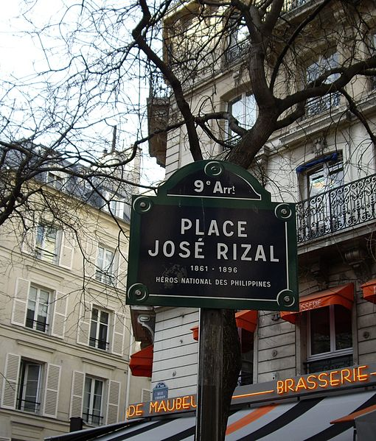

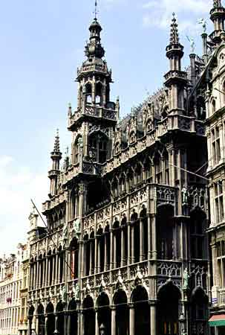

**2 February 1890**Rizal arrived Brussels from Paris.

**15 April 1890**Rizal’s letter to his countrymen, "Sobre la nueva ortografia de la lengua tagala," was published in the La Solidaridad.

**28 May 1890**In a letter, he complained to M.H. del Pilar about the Filipinos indulging in gambling in Madrid. He said that Juan Luna and Valentin Ventura in Paris were complaining about it, as it became known already in the Philippines.

**29 July 1890**Rizal informed Mariano Ponce of his departure for Madrid on the 1st of August and his arrival there on the 3rd or the 4th day of the same month.

**31 July 1890**His essay "Sobre la indolencia de los Filipinos" was published in the La Solidaridad (second installment).

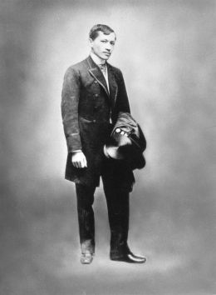

**15 August 1890**His essay "Sobre la Indolencia de los Filipinos was published in the Solidaridad (third installment).

**20 August 1890**He wrote to his brother and sisters advised about the persecution of the noble persons of Calamba, but to have patience since he was going to consult the Minister of Pardon and Justice of the Spanish government in Madrid.

**7 January 1891**Rizal wrote a very inspiring and interesting letter to P. Vicente Garcia, seeking from the latter a light with which to prepare himself (Rizal) to trend the path of the future. He said that the experience of old who has seen much of the world and studied more can supplement the youth’s few years and little knowledge.

**21 January 1891**In a letter, he broached to Jose Ma. Basa his idea of founding a college in Hong Kong where they would teach languages, sciences, and arts, patterned after the Jesuits Colleges.

**27 January 1891**Rizal left Madrid for Paris via Biarritz, after encountering all failures and difficulties in Madrid.

**11 February 1891**  
From Biarritz, Rizal wrote Mariano Ponce in Madrid that he was too occupied and could not send articles for the La Solidaridad. He offered his services of answering the attacks hurled against them in case Marcelo H. del Pilar and Antonio Luna could not answer.

**29 March 1891**He finished writing his book El Filibusterismo. He planned, however, of revising some chapters.



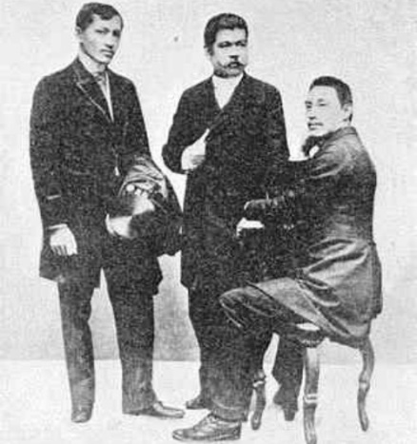

**8 April 1891**Rizal arrived at Brussels, from Paris. He immediately wrote a letter of congratulation to Antonio Luna in Madrid.

**30 May 1891**Rizal set ready for printing 20 chapters of the manuscript of the El Filibusterismo. He was waiting for an amount to defray the publication expense.

**13 June 1891**Rizal finished reviewing and correcting the manuscript of the Fili, except for the last three chapters.He left Brussels for Ghent.

**9 July 1891**  
He was financially hard up. He did not receive for three months up to this date any pension from home. He was living in the most difficult situation, renting a small room and eating the modest food in order to economize and able to publish the Fili. He had already pawned all his jewels.

**25 September 1891**  
Valentin Ventura sent to Rizal in Ghent 200 francs for the publication expenses of the Fili.

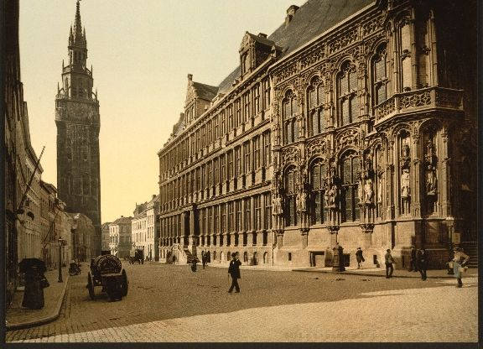

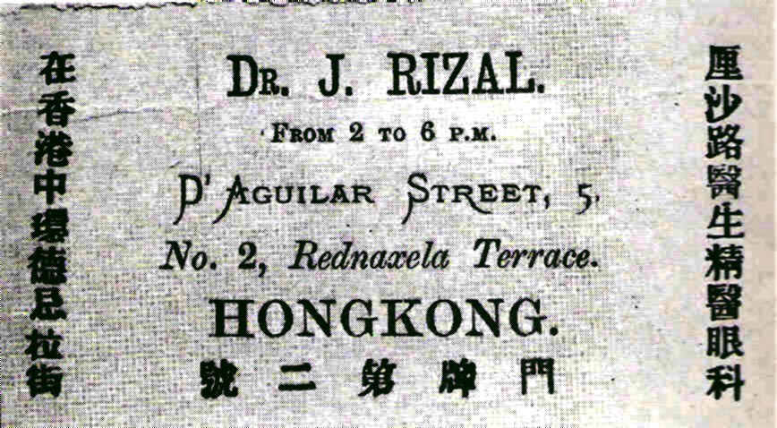

**21 June 1892**  
He wrote to Governor-General Despujol advising the latter of his arrival to the Philippines to take the few things of the family. Rizal was in Hongkong at this time, about to depart for the Philippines. He informed the Governor-General of his arrival in the Philippines ready to face whatever charges presented against him.

**26 June 1892**  
Rizal arrived in the Philippines from Hongkong on board the boat Don Juan. After having been inspected by the custom men, he boarded in the Oriente Hotel where he occupied room No. 22, facing the Binondo church. His sister, Lucia, accompanied him in his return to the Philippines. In the evening, he attended the reunion held in the house of Don Ong-junco, a Chinese mestizo, who was living in the district of Tondo. Here he met many Filipinos who were later arrested and executed as a consequence of the discovery of the Katipunan.

|  |  |  |
| --- | --- | --- |
| **15 July 1892** At 1:00 on the morning, Rizal was shipped on board the boat S. S. Cebu to Dapitan. He was given good cabin, but well guarded. | | |
|  |  |  |

**18 October 1891**  
Rizal left Marseilles for Hong Kong aboard the Melbourne. On board, the beauty of Mme. De Block amused him

**19 November 1891**  
In the evening Rizal arrived at Hong Kong.

**6 December 1891**  
Francisco Mercado, Paciano and his brother-in-law, Silvestre Ubaldo, escaped from the Philippines to avoid persecution, and arrived at Hong Kong to join him.

**January 1892**  
Everyday, after his medical practices in his clinic, he continued writing his third novel. It treated exclusively about the Tagalog customs, usages, virtues and defects. Meanwhile, his brother Paciano translated the Noli into Tagalog.

**15 February 1892**  
The Hong Kong Telegraph published the letter of Rizal signed Philippines in which he denounced the vandalistic actions of the friar manager of the Dominicans in destroying the houses of those who refused to pay the exorbitant rentals demanded of them in Calamba.



**Exile in Dapitan**

Upon his return to Manila in 1892, he formed a civic movement called La Liga Filipina. The league advocated these moderate social reforms through legal means, but was disbanded by the governor. At that time, he had already been declared an enemy of the state by the Spanish authorities because of the publication of his novel.

Rizal was implicated in the activities of the nascent rebellion and in July 1892, was deported to Dapitan in the province of Zamboanga, a peninsula of Mindanao. There he built a school, a hospital and a water supply system, and taught and engaged in farming and horticulture. Abaca, then the vital raw material for cordage and which Rizal and his students planted in the thousands, was a memorial.

The boys' school, which taught in Spanish, and included English as a foreign language (considered a prescient if unusual option then) was conceived by Rizal and antedated Gordonstoun with its aims of inculcating resourcefulness and self-sufficiency in young men. They would later enjoy successful lives as farmers and honest government officials. One, a Muslim, became a datu, and another, José Aseniero, who was with Rizal throughout the life of the school, became Governor of Zamboanga.

In Dapitan, the Jesuits mounted a great effort to secure his return to the fold led by Fray Sánchez, his former professor, who failed in his mission. The task was resumed by Fray Pastells, a prominent member of the Order. In a letter to Pastells, Rizal sails close to the ecumenism familiar to us today.

His best friend, professor Ferdinand Blumentritt, kept him in touch with European friends and fellow-scientists who wrote a stream of letters which arrived in Dutch, French, German and English and which baffled the censors, delaying their transmittal. Those four years of his exile coincided with the development of the Philippine Revolution from inception and to its final breakout, which, from the viewpoint of the court which was to try him, suggested his complicity in it.

He condemned the uprising, although all the members of the Katipunan had made him their honorary president and had used his name as a cry for war, unity, and liberty.

He is known to making the resolution of bearing personal sacrifice instead of the incoming revolution, believing that a peaceful stand is the best way to avoid further suffering in the country and loss of Filipino lives.

In Dapitan, Rizal wrote "Haec Est Sibylla Cumana", a parlor-game for his students, with questions and answers for which a wooden top was used. In 2004, Jean Paul Verstraeten traced this book and the wooden top, as well as Rizal's personal watch, spoon and salter.

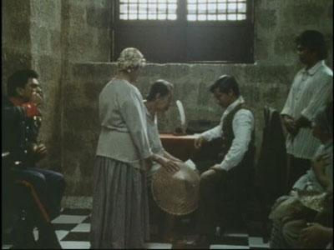

**Arrest and trial**

By 1896, the rebellion fomented by the Katipunan, a militant secret society, had become a full-blown revolution, proving to be a nationwide uprising.

Rizal had earlier volunteered his services as a doctor in Cuba and was given leave by Governor-General Ramón Blanco to serve in Cuba to minister to victims of yellow fever. Rizal and Josephine left Dapitan on August 1, 1896, with letter of recommendation from Blanco.

Rizal was arrested en route to Cuba via Spain and was imprisoned in Barcelona on October 6, 1896. He was sent back the same day to Manila to stand trial as he was implicated in the revolution through his association with members of the Katipunan. During the entire passage, he was unchained, no Spaniard laid a hand on him, and had many opportunities to escape but refused to do so.

While imprisoned in Fort Santiago, he issued a manifesto disavowing the current revolution in its present state and declaring that the education of Filipinos and their achievement of a national identity were prerequisites to freedom.

Rizal was tried before a court-martial for rebellion, sedition, and conspiracy, was convicted on all three charges, and sentenced to death. Blanco, who was sympathetic to Rizal, had been forced out of office. The friars, led by then Archbishop of Manila Bernardino Nozaleda, had 'intercalated' Camilo de Polavieja in his stead, as the new Spanish Governor-General of the Philippines after pressuring Queen-Regent Maria Cristina of Spain, thus sealing Rizal's fate.

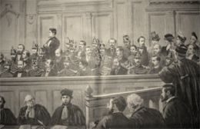

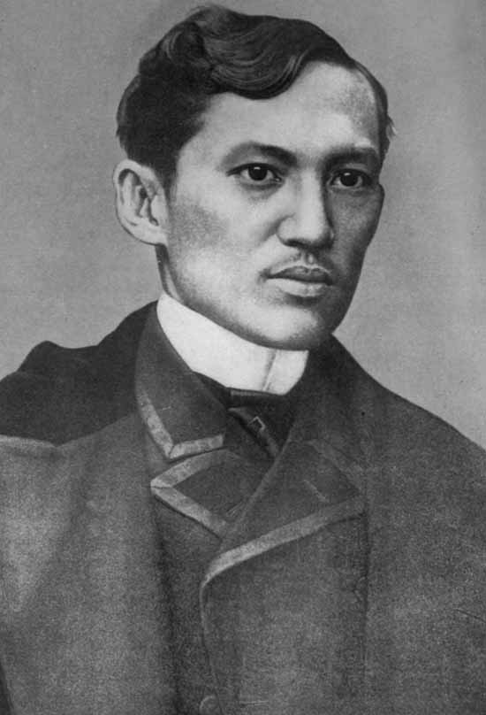

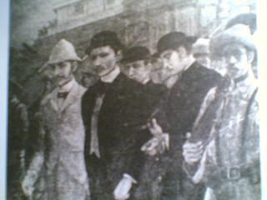

**Execution**

Moments before his execution on December 30, 1896, by a squad of Filipino soldiers of the Spanish Army, a backup force of regular Spanish Army troops stood ready to shoot the executioners should they fail to obey orders.[37] The Spanish Army Surgeon General requested to take his pulse: it was normal. Aware of this the Sergeant commanding the backup force hushed his men to silence when they began raising "vivas" with the highly partisan crowd of Peninsular and Mestizo Spaniards. His last words were those of Jesus Christ: "consummatum est",--it is finished.

He was secretly buried in Pacò Cemetery in Manila with no identification on his grave. His sister Narcisa toured all possible gravesites and found freshly turned earth at the cemetery with guards posted at the gate. Assuming this could be the most likely spot, there never having any ground burials, she made a gift to the caretaker to mark the site "RPJ", Rizal's initials in reverse.

His undated poem, Mi último adiós believed to be written a few days before his execution, was hidden in an alcohol stove, which was later handed to his family with his few remaining possessions, including the final letters and his last bequests.

During their visit, Rizal reminded his sisters in English, "There is something inside it", referring to the alcohol stove given by the Pardo de Taveras which was to be returned after his execution, thereby emphasizing the importance of the poem. This instruction was followed by another, "Look in my shoes", in which another item was secreted. Exhumation of his remains in August 1898, under American rule, revealed he had been uncoffined, his burial not on sanctified ground granted the 'confessed' faithful, and whatever was in his shoes had disintegrated.

In his letter to his family he wrote: "Treat our aged parents as you would wish to be treated...Love them greatly in memory of me...December 30, 1896."[20] He gave his family instructions for his burial: "Bury me in the ground. Place a stone and a cross over it. My name, the date of my birth and of my death. Nothing more. If later you wish to surround my grave with a fence, you can do it. No anniversaries."

In his final letter, to Blumentritt – Tomorrow at 7, I shall be shot; but I am innocent of the crime of rebellion. I am going to die with a tranquil conscience.

Rizal is believed to be the first Filipino revolutionary whose death is attributed entirely to his work as a writer; and through dissent and civil disobedience enabled him to successfully destroy Spain's moral primacy to rule. He also bequeathed a book personally bound by him in Dapitan to his 'best and dearest friend.' When Blumentritt received it in his hometown Litoměřice (Leitmeritz) he broke down and wept.

